Lesson Plan Designed by: Eugene White

IDAHO magazine article: Any 4 IDAHO magazine articles

8th Grade Social Studies:
Five Themes of Geography

Estimated time: 50 minutes

Standards: IDAHO CONTENT STANDARDS, Goal 2,1: Analyze the spatial organizations of people and environment on the earth’s surface.

Theme: We are all citizens of the world. We are all one people. We are responsible to each other.

Skill: Students will apply the five themes of geography to a reading from Idaho Magazine. They will demonstrate their ability to work in groups. They will prepare and present information to the class.

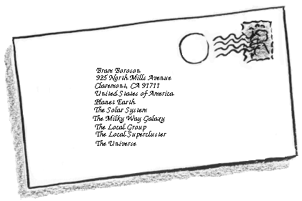
Gaining Attention: The class will begin with a film clip from the play “Our Town,” by Thornton Wilder. The address expresses the geography theme of location. (Check your media library for the movie version of “Our Town,” if not available you may have students act it out.)

Jane Crofut
The Crofut Farm, Grover’s Corners

Sutton County, New Hampshire
United States of America,
Continent of North America,
Western Hemisphere, Earth, Solar System, Universe; Mind of God.
In the scene there is a letter addressed to Jane Crofut from her minister.

He wrote the address like this: Jane Crofut; The Crofut Farm; Grover’s Corners; Sutton County; New Hampshire; United States of America; Continent of North America; Western Hemisphere; the Earth; the Solar System; the Universe; the Mind of God.

Following the clip the teacher will read the address again, showing on Power Point the locations of each of the address items with maps or pictures. The first will be of a country farm; the last will be the Universe (a picture of the vastness of space).

Learner Objective: Students will work in groups to review an article from Idaho Magazine. Students will analyze the article and identify examples of the five themes of geography. Students will demonstrate their understand of the elements of geography by categorizing and reporting their findings to the class.

Stimulating Recall of Prerequisite Learning: The previous lessons covered the definition of the five themes and the teacher has demonstrated the use of the various themes. A quick overhead presentation will refresh their understanding and the teacher will conduct a question and answer exercise to make sure the concepts have been learned.

- Location
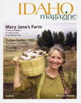
  - Relative Location
  - Absolute Location
- Place
  - Human Characteristics
  - Physical Characteristics
- Human-Environmental Interactions
  - Humans adapt to the environment
  - Humans modify the environment
  - Humans depend on the environment
- Movement
  - People
  - Goods
  - Ideas
- Regions
  - Formal
  - Functional
  - Vernacular (perceptual)

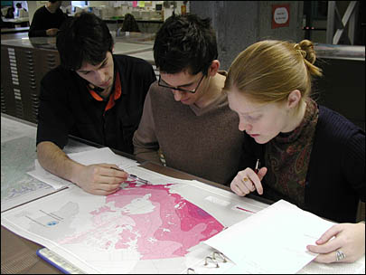
Stimulating Material:

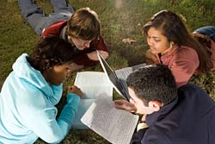
1. Students will form into teacher-assigned groups of four with the following assigned roles:

1 student will be responsible for reading;
1 student will be responsible for making
sure notes are taken;
1 student will be responsible for leading in
the discovery of the themes; and
1 student will be responsible for the
presentation.

Every member of the group will be responsible for participation in each group activity; the designated person will only serve as the “leader” for that activity. For instance the person responsible for reading is not required to read, rather he/she is responsible for making sure everyone has read the material.

2. Each group will be given a different article from Idaho Magazine.

3. The groups will read the article either individually or as a group per the decision of the student responsible for reading.

4. The group will identify examples of the five themes of geography under the leadership of the student responsible for the discovery of the themes.

5. The findings will be recorded in a manner determined by the student responsible for recording their findings.

6. The group will determine the most effective means of presenting their findings and then present their findings under the guidance of the student responsible for presentation.

7. Groups will present their findings by first briefly summarizing the article they were assigned and then the elements of geography they were able to identify.

Desired Behavior: Working in teams, students will review articles, analyze material and identify examples of the five themes of geography. They will assist each other in any difficulties in understanding the concepts. Students will categorize and record their finding appropriately and present their findings to the class.

Feedback: Students will be offered feedback form the teacher during each step of the lesson. The teacher will monitor the progress of each group offering insight and correction when necessary. The teacher will also give feedback when students are making reports, probing them for more information and clarification. Students will offer feedback to each other as well.

Assessing the Behavior: Students will be assessed on the proper completion of their reports. They will be assessed on their final reports and their work within their groups. Each group member will give his or her team members a one-to-five evaluation based upon the teamwork done by that individual (five being the highest and one being the lowest).


Closure: A quick closing exercise will ask the students to write their address or “location” in the fashion that the minister addressed the letter to Jane Crofut in Our Town. The teacher will place the envelope picture back on the projector as an example. This will be the student’s ticket out of class.

